**REPORT**

**1.- Introduction/Business Problem**

In different countries of the world and in particular in the United States and Canada, there are more and more young people interested in learning other languages, such as Spanish.

Many of them, either individually or with their partners, would like to make the decision to travel, live and work in a country where Spanish is spoken to learn to speak the language well, understand its idioms and also learn about the local culture, history and customs.

Basically this experience could be had in Spain, or in a Latin American country (except Brazil where Portuguese is spoken). Usually Mexico City attracts the attention of young people, but also Madrid, which is the capital of Spain. Unfortunately, information of interest to young people is not always available regarding what these cities offer, which are the best neighborhoods and what services or places of interest they have nearby.

Following these lines, it is proposed to make a comparison between **Madrid** (capital of Spain) and **Mexico City** (capital of Mexico) segmenting and clustering the neighborhoods of both cities, in order to be able to provide information regarding their characteristics and the services they offer. In particular, neighborhoods where there is a greater presence of businesses will be differentiated from those closest to green areas and from others that might offer a more important presence of restaurants, cafes or similar venues.

The idea is to be able to find those particular neighborhoods in the city that offer the closest proximity to these 3 types of services at the same time, thinking that potential travellers might be interested in being close to places where they can find a job, but also where they might be able to have fun and be close to parks.

The abovementioned information and its analysis will be delivered through a web page written in English and linked to Google so that people who speak English and who are interested in studying Spanish and living abroad for some time are able to reach it. It is also possible to contact youth organizations or local governments in the United States and Canada, and share with them the resulting information, so that they can send it respectively to their contacts or disseminate among interested citizens.

**2.- Data**

A comparison of neighborhoods and segmentation of Mexico City and Madrid will be made, using the Foursquare application, from which those neighborhoods that may meet the conditions sought will be analyzed; particularly neighborhoods with an important presence of businesses, others with cafes and restaurants, as well as neighborhoods close to parks and green areas. Also those that meet all these criteria at the same time or are located at a short distance from these services will be highlighted.

Concerning other sources of information, and knowing that young people may also be interested in learning more about the culture and history of the country, the location of the most important museums and other important landmarks of the city will be identified, which may influence the choice of the more convenient neighborhoods.

Other data of interest will be added, such as country information: GDP income, unemployment level, and other demographic indicators.

**3.- Methodology**

The same methodology was applied to both Mexico City and Madrid. The analysis carried out on Madrid is explained below:

The analysis began by looking for information regarding the postal codes of Madrid, with the aim of defining its Boroughs and Neighborhoods. This information is available on Wikipedia, from where it was possible to extract the data manually, since there were not so many records. This also allowed the information to be correctly formatted from the start, in a text file. It was necessary to add, for each neighborhood, its Latitude and Longitude, which was obtained from Googlemaps. In some cases, the Googlemaps map a polygon that represents the neighborhood and then the central point of the polygon was taken as latitude and longitude. In the case of not having a polygon, an important point of interest was taken in each Neighborhood, which was indicated by Googlemaps. Finally, everything was recorded in a text file with UTF-8 encoding to avoid problems on GitHub or with reading the text file from the Jupyter Notebook. The information fields of the text file are:

**Postal Code – Borough – Neighborhood – Latitude -Longitude**

This is a screen shot of the data file in csv format:

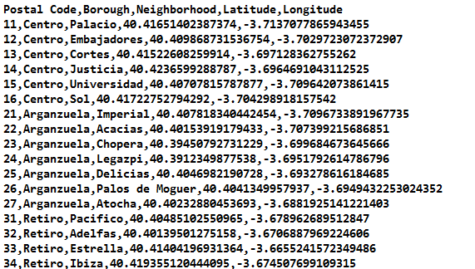

A Jupyter Notebook was prepared to bring this text file to a Pandas Dataframe of the following type:

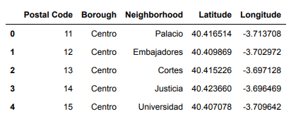

This Pandas has a total of 21 Boroughs and 131 Neighborhoods.

The map of Madrid was then prepared with the Neighborhoods superimposed. The following result was obtained:

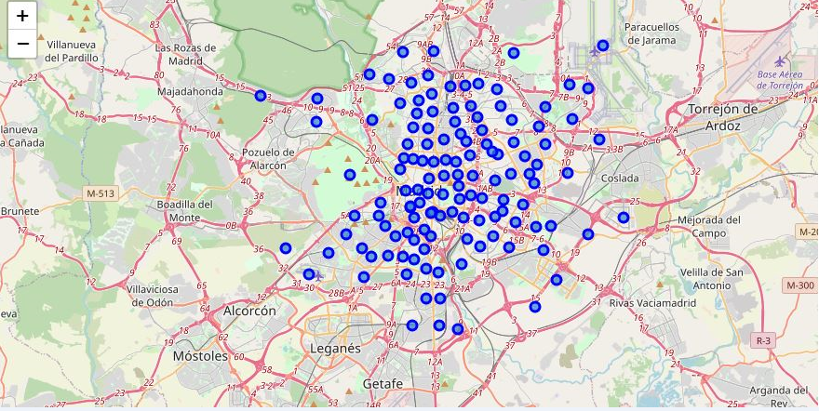

Next, an API was prepared to connect with the FourSquare Service, which made it possible to send a request with information about the venues for one of the neighborhoods, to see how everything worked before performing an analysis for all the neighborhoods. The request returned a .json file with the response. As a next step, a function was prepared to extract the category of the venues from that .json file and the .json file was also cleaned and structured to leave it as a Pandas Dataframe, which is shown below. It contains the information of the venues closest to one of the selected neighborhoods:

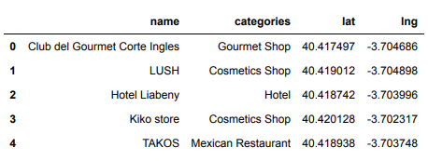

In this case, a total of 80 venues were obtained for one of the neighborhoods.

With this base, the exploration of all the Neighborhoods of Madrid began, for which a function was created to repeat the same previous process, but in all the Neighborhoods. The result was a Pandas Dataframe of 3439 rows with the following structure:

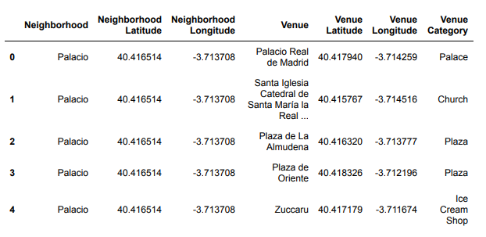

Next, it was identified how many unique categories of venues could be found. A total of 277 unique categories were ridentified. With this, a new Pandas Dataframe of 3439 rows (one for each venue) and with the 277 unique categories was prepared to identify the type of venue.

From there, the venues of the previous Dataframe were grouped for each neighborhood, obtaining a Dataframe with a row for each neighborhood and 277 columns of unique categories. The value in each column indicated the average frequency of occurrence of each venue for each neighborhood. Next, a snapshot of the resulting dataframe is shared:

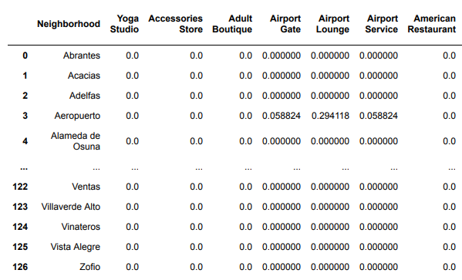

With this result, for each neighborhood it is possible to obtain the venues with the highest frequency, according to the following structure:

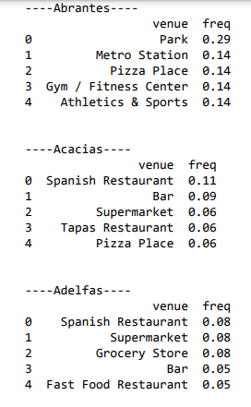

This information was also put into a Pandas Dataframe to sort the top 10 venues in descending order for each Neighborhood:

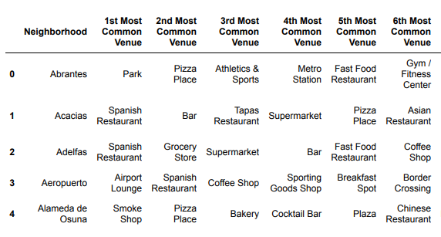

After finishing the abovementioned analysis, all was set to carry out the Clustering of Neighborhoods. A priori it was decided to start a k-means clustering with 12 clusters. The following array was obtained with the assignment of each Neighborhood to a specific cluster.

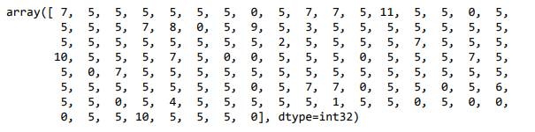

This allows the creation of a new dataframe that includes the cluster for each Neighborhood, in addition to the top 10 venues, according to the following structure:

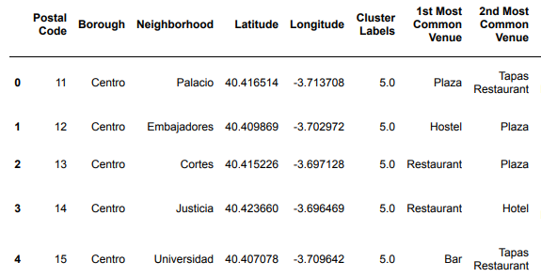

Finally, it is possible to obtain a map with the neighborhoods assigned to different clusters:

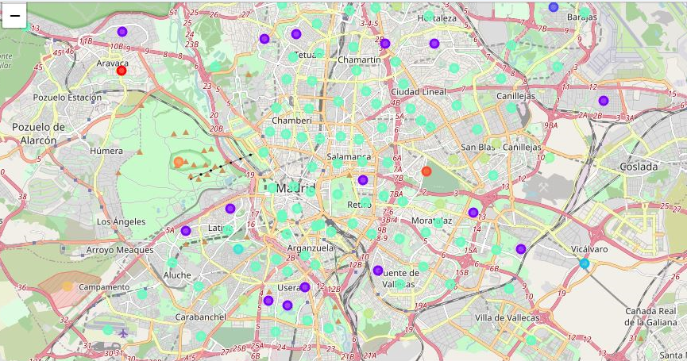

And also obtain a Dataframe with the information of the Neighborhoods in each of the 12 Clusters. As an example, the result is shown for Cluster 0, which in this case could be called “**Spanish Restaurants**”.

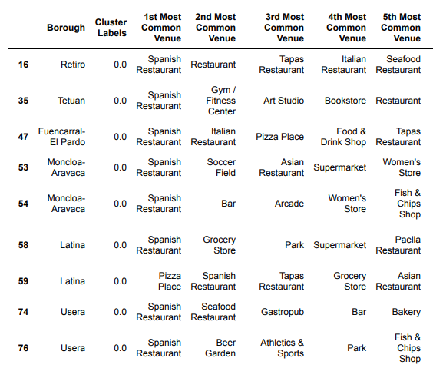

Also the result for Cluster 7 that could be called "Park"

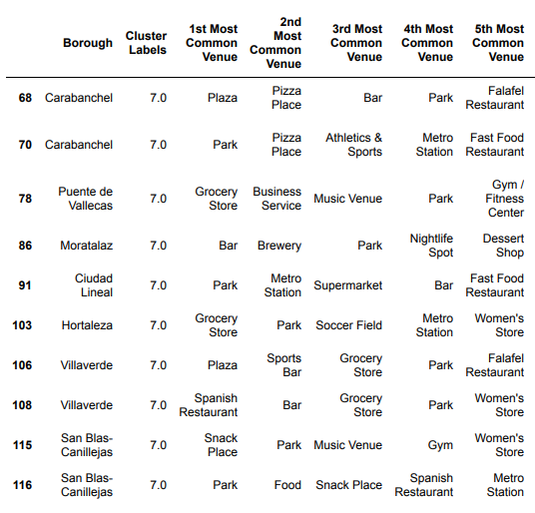

Finally, the above information was complemented with other data of interest, such as the location of important landmarks (information retrieved from Google Maps), as well as general information about the country such as per capita income or unemployment level, among others. which were obtained from Wikipedia.

**4.- Results**

In the case of Madrid, the result of the Clustering yields the following thematic organization of the Boroughs and some of their Neighborhoods:

|  |  |  |  |
| --- | --- | --- | --- |
| **Cluster Number** | **Cluster Type/Name** | **Boroughs** | **Neighborhood** |
| 11 | Athletics / Gym | **Moncloa-Aravaca** | 56 |
| 10 | Soccer Field | Fuencarral-El Pardo  Ciudad Lineal | 44  90 |
| 9 | Trail | **Moncloa-Aravaca** | 50 |
| 8 | Golf Course | Latina | 61 |
| 7 | Park | Carabanchel  Puente de Vallecas  Moratalaz  Ciudad Lineal  Hortaleza  Villa Verde  **San Blas-Canillejas** | 68, 70  78  86  91  103  106,108  115-116 |
| 6 | Electronics Stores | **San Blas Canillejas** | 118 |
| 5 | Hotels and Restaurants | Centro  **San Blas-Canillejas**  Barajas | 0,1,2,3,4  121  122-123-124-126 |
| 4 | Bed & Breakfast | Carabanchel | 66 |
| 3 | Mediterranean Restaurant | Vicalvaro | 111 |
| 2 | Canal Lock | Fuencarral-El Pardo | 43 |
| 1 | Bakery | Barajas | 125 |
| 0 | Spanish Restaurant | Retiro  Tetuán  Fuencarral-El Pardo  **Moncloa-Aravaca**  Latina  Usera  Puente de Vallecas  Moratalaz  Ciudad Lineal  Hortaleza  Vicalvaro  **San Blas-Canillejas** | 16  35  47  53-54  58-59  74,76,77  79  85  97  101  113  119 |

From the previous data, it is possible to see that some Boroughs are repeated in several categories, which is precisely what we want to look for, Boroughs that can offer different services and entertainment at the same time, for someone who wants to live in the city for a while, with the goal of learning Spanish. The Boroughs that stand out and their categories are as follows:

**Moncloa-Aravaca**: Athletics / Gym; Trail; Spanish Restaurant

**San Blas- Canillejas**: Parks, Electronics Stores, Hotels and Restaurants, Spanish Restaurants

Both Boroughs look interesting, however the analysis was complemented to decide which one of them is the more convenient.

According to Googlemaps, this is where **Moncloa-Aravaca** is located (signaled with a red heart on the map of Madrid). As a first comment, it is a sector of the city that is very close to the city center (blue circle) and it is also worth mentioning that there are universities in the area.

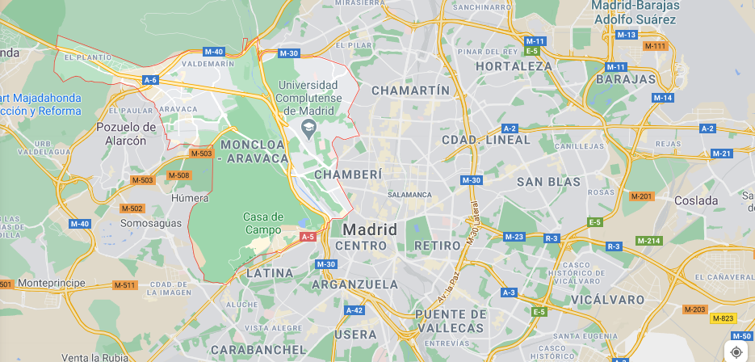

Next, this is where **San Blas-Canillejas** is located (signaled with a red heart on the map of Madrid). As a first comment, it is an area that, although close to the airport, it is unfortunately farther from the city center (blue circle).

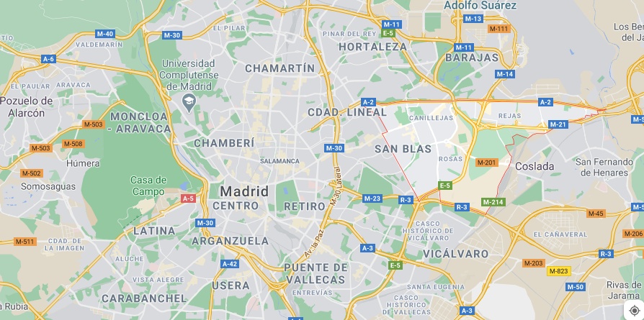

By enlarging the map around both places, the proximity to other landmarks was analyzed. The result was the following:

**Moncloa-Aravaca**

* Hospital
* Complutense University of Madrid
* Polytechnic University of Madrid
* The Museum of America
* Madrid Amusement Park
* Very close to the downtown area of Madrid.

**San Blas-Canillejas**

* Parks
* Airport

Additionally, Both Boroughs are equidistant from the new Chamartín Business District.

As a result of the previous analysis, Moncloa-Aravaca is proposed as the best candidate to live in Madrid for people who want to study Spanish. Besides, the Google Maps description for the Moncloa-Aravaca Borough is the following:

“The tree-lined Moncloa-Aravaca neighborhood is home to the large Casa de Campo park, where the Cable Car takes visitors a few steps from the Madrid Zoo Aquarium and the Amusement Park. Quiet terraced cafes line the Manzanares River and the Parque del Oeste promenade. In the afternoon, crowds enjoy sunset views from the Egyptian Temple of Debod. The students hang out in the bars near the Moncloa universities. "

In addition, the *Life Quality Score for Madrid* should also be considered (Source: <https://teleport.org/cities/madrid/>). In this analysis such criteria as Safety, Healthcare, Leisure & Culture and Tolerance stand out, which may be important aspects to consider.

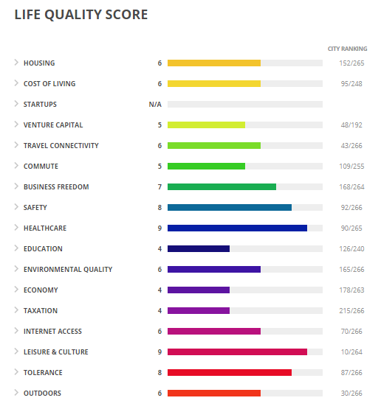

With respect to other complementary information, we have:

* GDP per capita : **USD 33,711 (2019)**
* Unemployment level in Spain : **13.96% (2019)**
* Inhabitants of the city of Madrid : **6.6 million (2019)**
* Number of Inhabitants in Moncloa- Aravaca: **116,903 (2017)**

In the case of Mexico City, the result of the Clustering yields the following thematic organization for the Boroughs and some of their Neighborhoods:

|  |  |  |  |
| --- | --- | --- | --- |
| **Cluster Number** | **Cluster Type/Name** | **Boroughs** | **Neighborhood** |
| 11 | Office | **Coyoacán** | 21,22 |
| 10 | Mixed |  |  |
| 9 | Pet Store | Azcapotzalco | 9 |
| 8 | History Museum | **Miguel Hidalgo** | 53 |
| 7 | Mobile Phone Shops | **Del Iztapalapa** | 45 |
| 6 | Mixed venues |  |  |
| 5 | Flea Market | Tiahuac | 67 |
| 4 | Mixed venues |  |  |
| 3 | Gym /Sports | **Iztacalco**  **Del. Iztapalapa** | 39  49 |
| 2 | Coffee Shop / Bakery | **Del. Iztapalapa** | 47 |
| 1 | Rental Car | Azcapotzalco | 4 |
| 0 | Mexican Restaurant / Taco Place | Alvaro Obregon  Azcapotzalco  Benito Juárez  Coyoacán  Cuauhtemoc  Gustavo a. Madero  **Iztacalco**  **Del. Iztapalapa**  Mag. Contreras  **Miguel Hidalgo**  Venustiano Carr. | 1,2  5,6  16  20  29  35  37, 38, 40  42, 43, 46, 48  50, 51  54  70, 73 |

From the previous data, it is possible to see that some Boroughs are repeated in several categories, which is precisely what we want to look for: Boroughs that can offer different services and entertainment at the same time, which is deemed important for someone wanting to live in the city for a while, with the goal of learning Spanish.

The Boroughs that stand out and their categories are as follows:

**Iztapalapa**: Mobile Phone Shops; Gym-Sports; Coffee Shops-Bakeries; Mexican Restaurant.

**Iztacalco**: Gym-Sports; Mexican Restaurant

**Miguel Hidalgo**: Mexican Restaurant, History Museum

Of the above, the Borough with the most services is **Iztapalapa**, however it is necessary to complement the analysis to decide which one is better.

According to Googlemaps, this is where Iztapalapa is located (signaled with a red dot). As a first comment, it is a sector of the city that is very far from the city center.

De los antecedentes anteriores, es posible ver que se repiten algunos Boroughs en varias categorías, que es precisamente lo que se quiere buscar, Boroughs que puedan ofrecer distintos servicios y entretenciones a la vez, para alguien que quiera vivir un tiempo en la ciudad, con el objetivo de aprender español. Los Boroughs que destacan y sus categorías son los siguientes:

**Del. Iztapalapa**: Mobile Phone Shops; Gym-Sports; Coffee Shops-Bakeries; Mexican Restaurant

**Iztacalco**:Gym-Sports; Mexican Restaurant

**Miguel Hidalgo**: Mexican Restaurant, History Museum

De los anteriores, el Borough que se ve con más servicios es Del. Iztapalapa, sin embargo es necesario complementar el análisis para decidir cuál es mejor.

According to Googlemaps, this is where **Del. Iztapalapa** is located (signaled with a red dot on the map of Mexico City). As a first comment, it is an area of the city that is very far from the city center (Blue Circle).

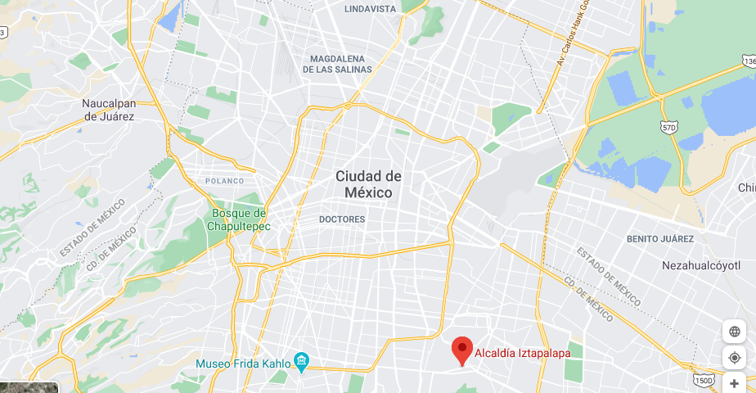

According to Googlemaps, this is where **Iztacalco** is located (signaled with a red heart on the Map of Mexico City). As a first comment, it is a Borough that is quite close to the city center.

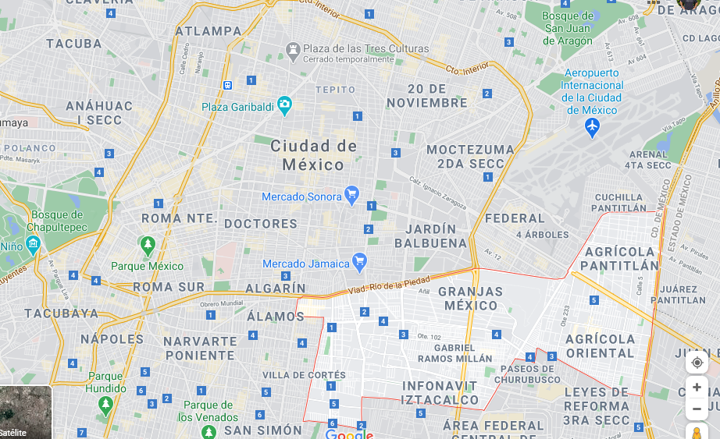

Finally, according to Googlemaps, this is where **Miguel Hidalgo** is located (signaled with a red heart on the map of Mexico City). As a first comment, it is a Borough very close to the city center, which also has a museum and a large park.

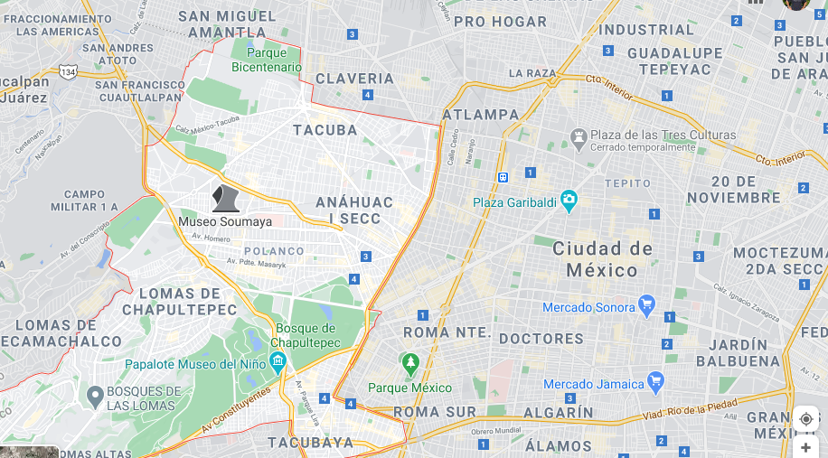

By enlarging the map, the proximity to other landmarks was analyzed. The result was as following:

**Iztacalco**

* Food Market

**Miguel Hidalgo**

* Anthropology National Museum
* Park
* Spanish Hospital
* Military Center Hospital
* Soumaya Museum
* Hippodrome

As a result of the previous analysis, **Miguel Hidalgo** is proposed as the best candidate to live in Mexico City for people who want to study Spanish and learn about history, culture and also enjoy free time.

**The description given by Google Maps of Miguel Hidalgo is as follows:**

“Miguel Hidalgo mixes exclusive areas like Polanco, characterized by its sophisticated gastronomy and luxury brand stores, with simple residential districts like Escandon. The elegant Soumaya Museum houses works by great masters and sculptures by Rodin, while the National Museum of Anthropology displays artifacts from the Mayan period onwards. Within the extensive Bosque de Chapultepec park, the top of Castillo de Chapultepec (Chapultepec Castle) offers views of the entire city. "

In addition, the *Life Quality Score for Mexico City* should also be considered (Source: <https://teleport.org/cities/mexico-city/>). In this analysis such criteria as Living Costs as well as Leisure & Culture may be important aspects to consider.

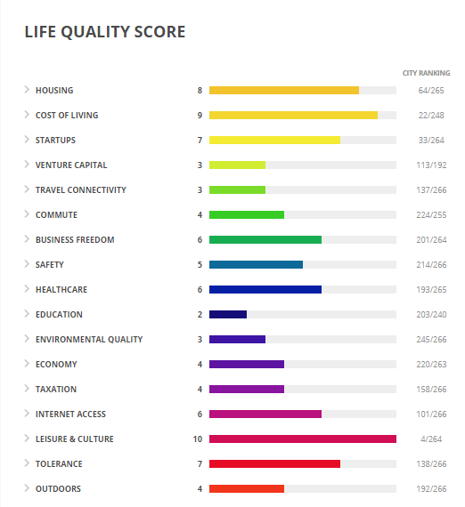

With respect to other complementary information, we have:

* GDP per capita : **USD 17,881 (2019)**
* Unemployment level in Spain : **5% (2019)**
* Inhabitants of the city of Madrid : **8.8 million (2015)**
* Number of Inhabitants in Moncloa- Aravaca: **364,000 (2015)**

**5.- Discussion**

Based on the data provided in the previous section, a Borough of Madrid (Moncloa-Aravaca) and another of Mexico City (Miguel Hidalgo) were suggested for those who want to live and work for a time in a capital city where Spanish is spoken.

It is not easy to compare countries or cities. Rather, the analysis carried out shows the services and activities that a person could access in any of the two places indicated, but it really is difficult to say which is better.

Everything will depend on the personal taste. On the one hand, if someone prefers travelling to a developed country located in the old continent with a higher per capita income and with better Safety, Healthcare, Leisure & Culture and Tolerance scores, probably Madrid should be chosen (and the Moncloa-Aravaca Borough). On the other hand, if someone would rather visit a country closer to the United States, a developing country, with a lower per capita income, then Mexico City and the Miguel Hidalgo Borough should be chosen. Notwithstanding the above, it is clear that Madrid has more category wins according to the Life Quality Score.

If someone wants to consider other variables to compare both cities in other aspects, the website <https://teleport.org/compare/madrid-and-mexico-city/> provides additional data to make a comparison. Here is the information for Madrid and Mexico City:

|  |  |  |
| --- | --- | --- |
|  | **Madrid** | **Mexico City** |
| **Small apartment median rent/month** | $870 | **$520** |
| **Medium apartment median rent/month** | $1.200 | **$710** |
| **Cost of broadband internet connection** | $35 | **$21** |
| **Cost of movie ticket** | $11 | **$4** |
| **Monthly fitness club membership** | **$46** | $64 |
| **Monthly Public Transport** | $71 | **$18** |
| **Traffic! (the higher the index, the better)** | **0.68** | 0.24 |
| **Lunch** | $13 | **$6** |
| **Air quality** | **0.31** | 0.15 |
| **Cleanliness** | **0.51** | 0.28 |

In aspects related to Leisure and Culture, both cities are quite similar, and that is probably the main reason that makes it difficult to choose one city over the other:

|  |  |  |
| --- | --- | --- |
| **Venue** | **Index score**  **Madrid** | **Index Score Mexico City** |
| Museums | 0.88 | 1.00 |
| Historical Sites | 0.99 | 0.99 |
| Sport venues | 0.82 | 1.00 |
| City Ranking | 10/264 | 4/264 |

**6.- Conclusion**

The objective of defining the best Boroughs to live, study and learn about the culture, as well as the language, was carried out for the capital cities of two Spanish-speaking countries: Madrid (Spain) and Mexico City (Mexico). It is not easy to compare countries, nor cities, however information was provided as to allow making the best choice considering personal preferences. Without a doubt, both countries and cities deliver unique experiences.

Most of the analysis was carried out thanks to Data Science and the use of Python, Jupyter notebooks and data frames, as well as clustering. The use of different or more diverse or advanced tools might provide more insight into the the question that was analysed.